**Exercise: Deploy Your First Kubernetes Cluster**

So far, you have learned that Kubernetes is a mechanism to manage containers at scale and that there are more than 160+ certified providers to bootstrap a cluster.

Now it's time for you to deploy your first Kubernetes cluster.

This exercise will focus on provisioning a vagrant box and installing a Kubernetes cluster using k3s.

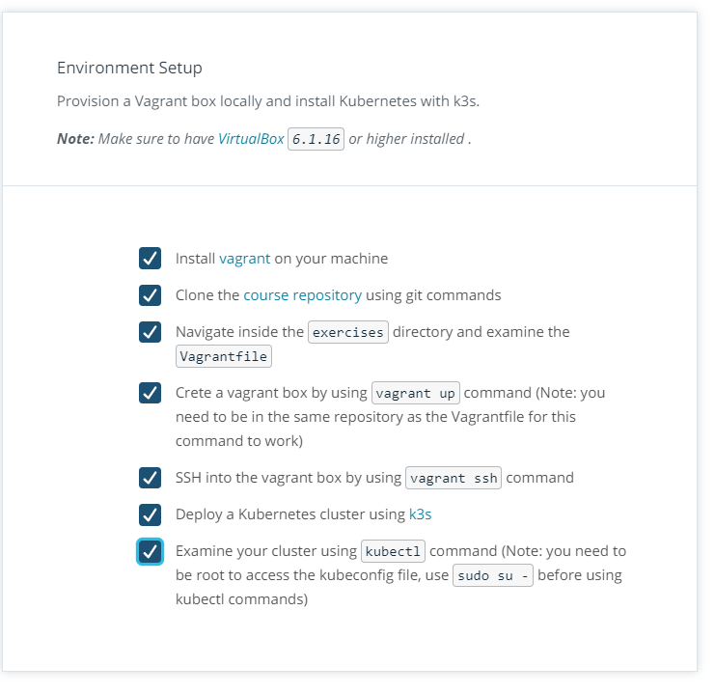

**Exercise**

Now you should have a Kubernetes cluster up and running. Examine the cluster and identity of the following details.

Use the blank space to record your answer if necessary,